Appendix A
Interim Gender pay gap report - Local Government Association

Employers in Great Britain with more than 250 staff are required by law to publish information showing the difference between what women earn as a group compared to what men earn as a group in a workplace. This is known as the gender pay gap.
Legally the LGA is not required to publish gender pay gap information. This is because it is divided into two separate employers – the LGA and the IDeA - neither of which employs more than 250 staff. However the LGA is committed to operating within the spirit of the legislation governing its member councils and therefore publishes its gender pay gap information.
In March 2017, the LGA and IDeA together employed 319 staff. Of these, 57% were female and 43% were male.
In March 2018, the LGA and IDeA together employed 332 staff. Of these, 58% were female and 42% were male
In September 2018, the LGA and IDeA together employed 369 staff. Of these, 58% were female and 42% were male
The LGA has in place a formal job evaluation process which it uses to set the grade of jobs across the organisation to ensure that we pay the salary that reflects the value of the role.
Difference in hourly rate
The mean hourly rate is the average hourly wage across the entire organisation - so the mean gender pay gap is a measure of the difference between women’s mean hourly wage and men’s mean hourly wage.
The median hourly rate is calculated by ranking all employees from the highest paid to the lowest paid, and taking the hourly wage of the person in the middle - so the median gender pay gap is the difference between women’s median hourly wage (the middle paid woman) and men’s median hourly wage (the middle paid man).
March 2017: Women’s mean hourly rate is 13.75% lower than men’s
March 2018: Women’s mean hourly rate is 13.53% lower than men’s
September 2018: Women’s mean hourly rate is 13% lower than men’s

March 2017: Women’s median hourly rate is 27.96% lower than men’s
March 2018: Women’s median hourly rate is 25.86% lower than men’s
September 2018: Women’s median hourly rate is 25.85% lower than men’s

Proportion of women in each pay quartile
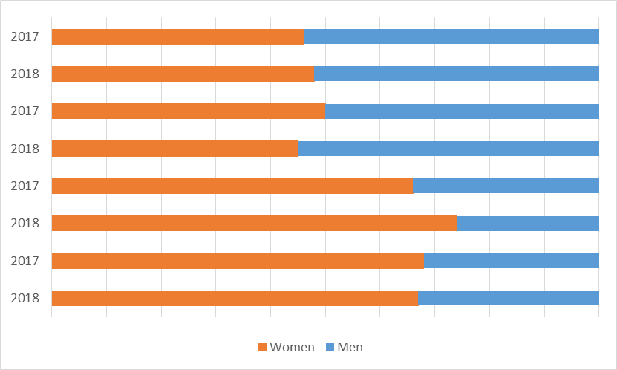
Pay quartiles are calculated by splitting all employees in an organisation into four even groups according to their level of pay. Looking at the proportion of women in each quartile gives an indication of women's representation at different levels of the organisation.
Top quartile (highest paid)
March 17: 46% of the top quartile are women
March 18: 48% of the top quartile are women

Upper middle quartile
March 17: 50% of the upper middle quartile are women
March 18: 45% of the upper middle quartile are women

Lower middle quartile
March 17: 66% of the lower middle quartile are women
March 18: 74% of the lower middle quartile are women

Lower quartile (lowest paid)
March 17: 68% of the lower quartile are women
March 18: 67% of the lower quartile are women

Who received bonus pay
The LGA does not pay bonuses.

